

**Digital Engagement Insights**

**Report**

Name: Vishakha Rongare

**Contents**

|  |  |  |
| --- | --- | --- |
| **Sr.No** | **Section** | **Page No.** |
| **1.** | **Title** | **3** |
| **2.** | **Objective** | **3** |
| **3.** | **Executive Summary** | **3** |
| **4.** | **Observations** | **4** |
| **5.** | **Dashboard Overview** | **8** |
| **6.** | **Conclusion: Insights, Recommendations, Future Improvements** | **10** |
| **7.** | **Appendix: Data Source & Preparation, Decision Visuals Used, Challenges & Solutions** | **11** |

# Title

**Digital Engagement: Social Media & Entertainment Analysis**

# Objective

To analyse user engagement across social media and entertainment platforms. The dashboard focuses on identifying:

* Platform preferences
* Peak user activity hours
* Content consumption behaviour
* Device usage trends

It delivers actionable insights to enhance engagement strategies and monetization models for content creators, marketers, and businesses.

# Executive Summary

This project analyses how **300,000 users** engage with social media and entertainment platforms. On average, users spend **4.15 hours** daily on **social** **media** and **4.7 hours** on **entertainment**, showing high digital activity. **Movies** and **Short** **Videos** are the **most** **preferred** **content** types, while **Netflix** is the **top** **entertainment** **platform**. **Smart** **TVs** and **smartphones** are the **main** **devices** used for **content consumption**. Age-based trends reveal different viewing habits, which can help in creating targeted content. With an average **entertainment** **spend** of **$250**, the findings support better engagement strategies and monetization planning.

# Observations

1. **Platform Distribution**  
   Users are evenly distributed across **TikTok, Twitter, Facebook, YouTube, and Instagram.**

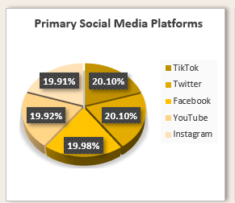

1. **Time Spent**
   * Avg social media Time: **4.15 hours/day**

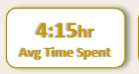

* + Avg Entertainment Time: **4.7 hours/day**

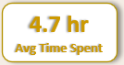

1. **Content Preferences**
   * Most consumed content: **Movies** and **Short Videos**

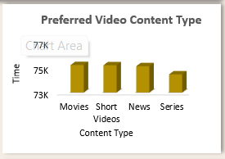

* + Entertainment categories: **Gaming, Music, and Video Content**

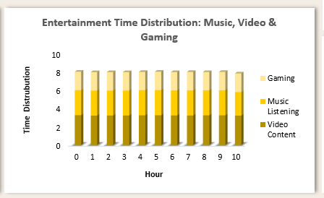

1. **User Base Size**
   * **300K** users were tracked

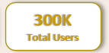

1. **Monetization Indicator**
   * Avg expenditure: **$250/user** on entertainment

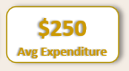

1. **Device Trends**
   * Most used: **Smart TVs** and **Smartphones**

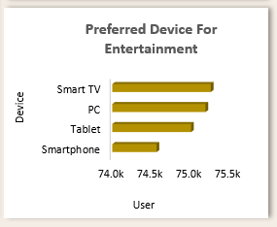

1. **Age Group Trends**
   * Age Segments: 13–20, 21–28, 29–36, 37–44, 45–52, 53–60, 61–65
   * Usage patterns varied across age groups, both in time spent and content preference.

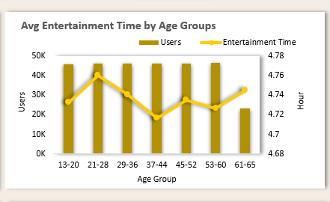

1. **Daily social media Time**  
   Users actively engage with social media for a continuous span of **7 hours (hour 1 to 7)**, reflecting high usage levels.

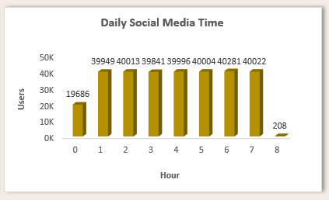

1. **Daily Messaging Time**  
   Messaging sees high engagement across **hour 1 to 5**, showing users are consistently active.

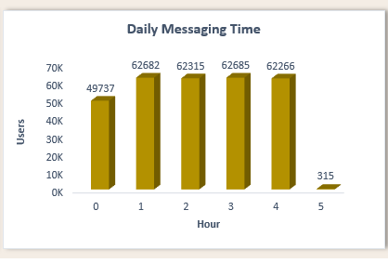

1. **Primary Social Media Goal**  
   Top reason: **News** (75.6K users), followed by **Entertainment** and **Education**

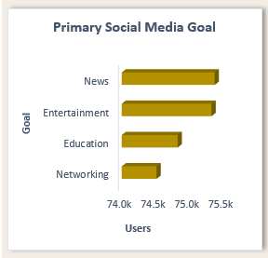

1. **Preferred Entertainment Platform**  
   Most preferred: **Netflix**, followed by **YouTube** and **Spotify**

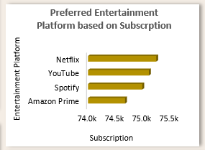

# Dashboard Overview

# 

**Key Visuals:**

* **Pie Chart:** Platform distribution across TikTok, Twitter, Facebook, YouTube, Instagram
* **Bar Charts:**
  + Daily Social Media & Messaging Time
  + Social Media Goals
  + Preferred Video Content
  + Entertainment Platform Usage
  + Device Preference
* **Line & Bar Combo**: Avg Entertainment Time by Age Group
* **Stacked Bar**: Entertainment category split (Gaming, Music, Video)
* **KPI Cards:**
  + Avg Social Media Time: 4.15 hrs
  + Avg Entertainment Time: 4.7 hrs
  + Avg Expenditure: $250
  + Total Users: 300K
  + Platforms: 5

**Interactive Element:**

* Single slicer for platform selection, filtering selected visuals

# Conclusion

**Insights:**

* High engagement with both social and entertainment content.
* Movies and Short Videos lead user preferences.
* Netflix outperforms other subscription services.
* Smartphones and Smart TVs are dominant devices.
* Different age groups show distinct behaviour, useful for targeting.

**Recommendations:**

* Invest in producing Movies and Short Video content.
* Optimize experiences for Smart TVs and mobile.
* Leverage Netflix for collaborative promotions.
* Tailor marketing by age group trends.
* Consider tiered/premium pricing models based on $250 average spend.

**Future Improvements:**

* Add real-time data updates for trend monitoring.
* Incorporate sentiment analysis for qualitative insights.
* Use predictive analytics to forecast user behaviour and suggest strategies.

# Appendix

**Data Source & Preparation:**

* Source: Kaggle (CSV Format)
* Cleaning:
  + Removed duplicates
  + Replaced missing numerical values with AVERAGE()
  + Categorical cleanup using logical substitution
  + Age groups created using IFS() function
  + Converted text-numbers to numeric types
  + Formatted for pivot tables and charts

**Visuals Used:**

* Pie, Bar, Combo (Line+Bar), Stacked Bar
* KPI Cards
* Filters/Slicers for user interactivity

**Challenges & Solutions:**

* Missing Data: Resolved using AVERAGE()
* Age Group Classification: Implemented using IFS()
* Formatting Issues: Converted data types and cleaned date/time
* Dashboard Usability: Added slicers and filters for better analysis experience